**Brain Teasers / Probability**

**Coin Toss**

* You are given 1000 coins. Among them, 1 coin has heads on both sides. The other 999 coins are fair. You randomly choose a coin and toss it 10 times. Each time, it turns up heads. What is the probability that the coin you chose is the UNFAIR one? 0.5
* You have an unfair coin, how do you generate even odds? Assign HT and TH to winning and losing.
* What is the expected number of tosses to see the first Head? 1/p
* What is the expected number of tosses to see 2 heads in a row? 1+p / p^2 , 3 heads = 1+p+p^2 / p^3
* What is the expected number of tosses to see n heads in a row? Sum from i = 0 to j – 1 p^I / p^j
* Two players are playing a coin toss game. Player A has n+1 coins. Player B has n coins. What is the probability that A will have MORE heads than B if both flip all their coins? 0.5
* 2 Players A and B alternate flipping a coin and the sequence of HT are recorded. Game ends when HT is seen and the person who tossed the tails wins. What is the probability A wins? 4/9

\*hint E(A|H) = 0 + ½ \* (1-P(A|H)

* What is the expected number of coin tosses to get n heads in a row? 2^n+1 – 2 (green book p119)
* If you keep tossing a coin, what is the expected number of tosses such that you can have HHH in a row? What is the expected tosses to have THH in a row? HHH = 14, THH = 8
* Keep flipping a coin until either HHH or THH occurs. What is the probability that you get an HHH before THH? 1/8
* If 2 players are allowed to choose their own triple sequences and the sequence which appears first wins, would you rather pick first or second?

**Dice**

* Throw 3 Dice one by one. What is probability that we obtain 3 points in increasing order? 5/54

P(all diff numbers) \* P(increasing order | all diff numbers) = (1 \* 5/6 \* 4/6) \* (1/6)

* You roll a dice. For each roll you are paid face value. If a roll gives 4,5,6 you can roll again. Once you get 1,2,3 the game stops. Whats the expected payoff of the game? (7)
* You can roll a dice up to 3 times. Every time you roll you have the option of taking what you got, or giving it up and rolling again. On the last roll you keep what you get. What is the expected payout and what is your strategy? 14/3 or 4.67
* 2 players bet on rolls of the total of 2 dice. Player A bets that the sum of 12 will occur first. Player B bets that 2 consecutive 7’s will occur first. What is the probability that A will win? 7/13
* You are allowed to roll a dice as many times you want and you are paid the number of dots, unless a 6 appears, in which case you lose everything you’ve earned thus far and the game stops. How much is the expected payoff? 5/6n +2.5 > n, so n = $14, E(X) = 6.15
* Expected number of rolls to see all six sides on a die? (coupon collector, 14.7)
* You have a 100 sided die. You are paid $1 for each number but after 1st roll you can pay $1 to roll again (you can reroll as many times as you want). What is expected value of this game? ($87.35)

**Russian Roulette**

* Russian roulette – I load it with 2 bullets side by side. I spin the gun and pull the trigger. You are alive. I will shoot you once more. Do you prefer if I spin again or not?
* Traditional Russian roulette with 1 bullet in the chamber. There are 2 players. The gun is spun only once before the game starts. Would you prefer to go 1st or 2nd? What is your probability of winning? Doesn’t matter, ½
* Now same as before, but we will spin after each turn. Will you choose to go 1st or 2nd? What is your probability of winning? Go first and have 5/11 change of winning (6/11 chance 1st person dies)
* If instead of 1 bullet, 2 bullets are put in randomly (NOT continuous). Your opponenet goes first and he is still alive. Should you spin the barrel? Yes
* What if instead the bullets are put in are continuous. Should you spin the barrel? No

**Cards**

* You are dealt 13 cards randomly from a pack of 52. What is the probability that your hand has exactly 2 aces?
* You pick a card from the deck and so does the dealer (without replacement). If you have a larger number you win. If the number is smaller or the same, dealer wins. What is your probability of winning? 8/17
* What is expected number of cards that need to be turned over in order to see first ace? 10.6
* 52 cards are randomly distributed to 4 players with each player getting 13 cards. What is the probability that each of them will get an ace? (52 \* 39 \* 26 \* 13) /( 52 \* 51 \* 50 \* 49)

**Others**

* Amoeba population p = sqrt(2)-1

\*hint (1-p)(p^2 + 2p – 1)

* Given a cube you can jump to a neighboring vertex with equal probability. What is the expected number of jumps until you reach the opposite side of the cube? 10

**Calculus Identities**

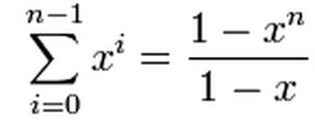

**Binomial Thm**

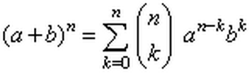

**Taylor Series**

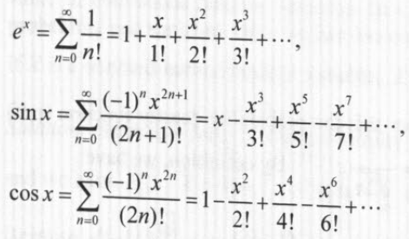

**Differential Equations**

**(1)**

If tex2html_wrap_inline201 and tex2html_wrap_inline203 are distinct real numbers (this happens if tex2html_wrap_inline205 ), then the general solution is

displaymath207

**(2)**

If tex2html_wrap_inline209 (which happens if tex2html_wrap_inline211 ), then the general solution is

displaymath213

**(3)**

If tex2html_wrap_inline201 and tex2html_wrap_inline203 are complex numbers (which happens if tex2html_wrap_inline219 ), then the general solution is

displaymath221

**Portfolio Optimization**

* Portfolio variance:  \sigma_p^2  = w_A^2 \sigma_A^2  + w_B^2 \sigma_B^2 + 2w_Aw_B  \sigma_{A} \sigma_{B} \rho_{AB}

**Linear Least Squares Regression**

\hat\beta = (X^TX)^{-1}X^Ty\ . 

Regression Assumptions:

1. X and Y relationship is linear
2. E(errors) = 0
3. Var(errors) = sigma squared, constant variance, uncorrelated errors
4. No perfect multicolliniearity
5. Errors and x’s are independent

**R**-**squared** is a statistical measure of how close the data are to the fitted regression line. It is also known as the coefficient of determination, or the coefficient of multiple determination for multiple regression.

**Options / Black Scholes**

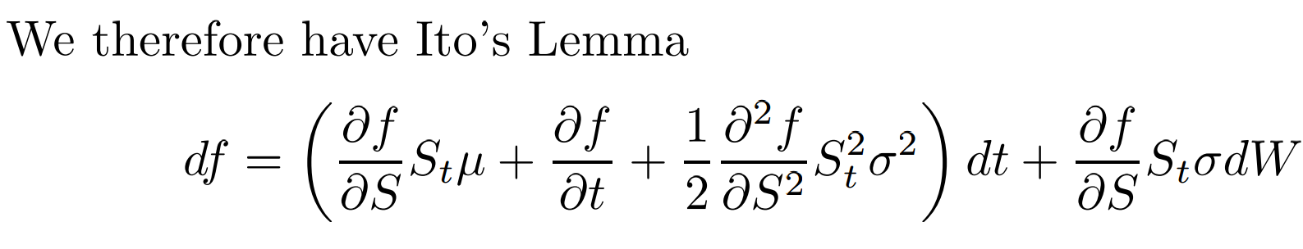

\frac{\partial V}{\partial t} + \frac{1}{2}\sigma^2 S^2 \frac{\partial^2 V}{\partial S^2} + rS\frac{\partial V}{\partial S} - rV = 0

Boundary Conditions:

\begin{align}
  C(0, t) &= 0\text{ for all }t \\
  C(S, t) &\rightarrow S\text{ as }S \rightarrow \infty \\
  C(S, T) &= \max\{S - K, 0\}
\end{align}

Black Scholes Assumptions:

1. Stock pays no dividends
2. Risk free interest rate is constant and known
3. Stock price follows a geometric Brownian motion with constant drift and volatility
4. No transaction costs or taxes (proceeds of short selling can be fully invested)
5. All securities are perfectly divisible
6. No arbitrage

Black-Scholes Call on European Stock  
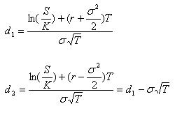

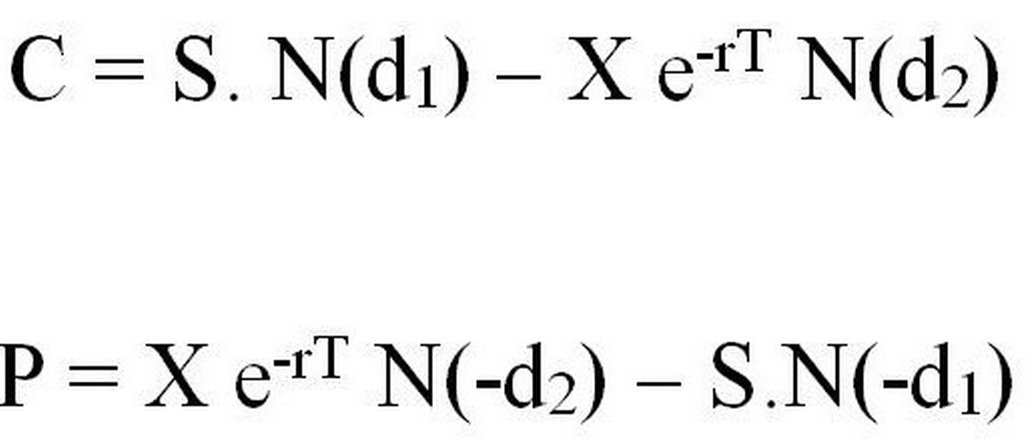

Delta Hedging:

Call -> Short Delta Shares of stock

Put -> Long Delta shares of stock

Price of ATM Call Approximation:



Gamma:

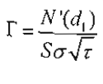

Vega:

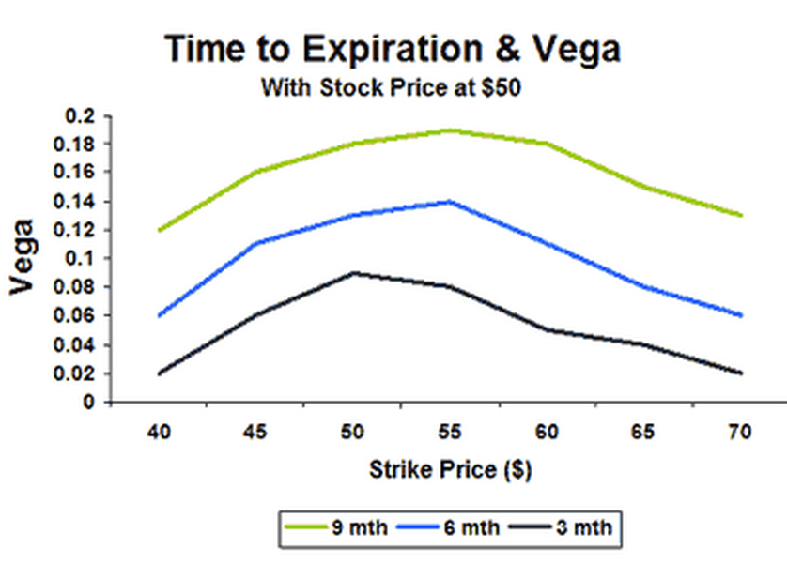



**Binary Call Option:**





**Binary Options**

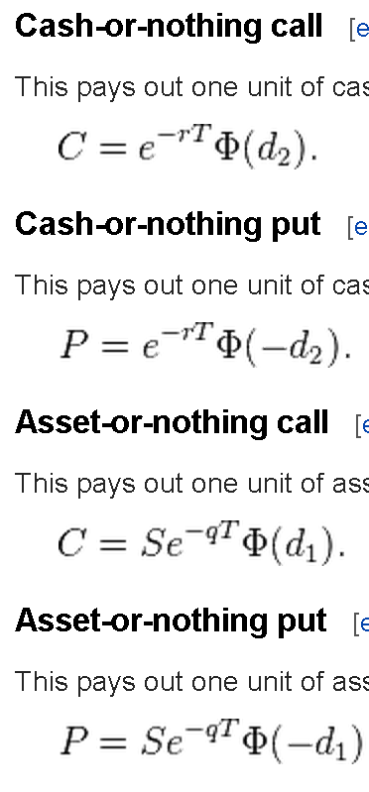

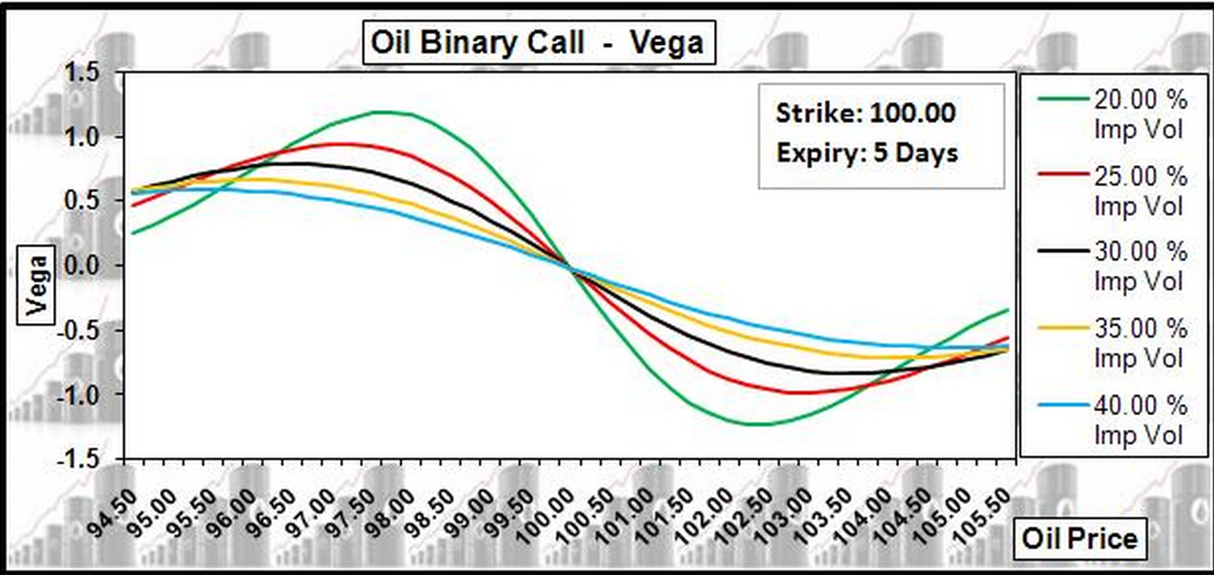

**Barrier Options** are option contracts whose payoff depends on whether or not the price of the underlying asset crosses a certain level during the option's lifetime. There are four basic types of barrier options that have slightly different payoff structures. These options can all be written as either puts or calls. When barrier options are sold they are created with a specified expiration date, a [strike price](http://www.wikinvest.com/wiki/Strike_price) and a barrier price.

* **Down-and-Out Barrier Options**: A down-and-out option gives the holder the right but not the obligation to buy (in the case of a call) or sell (in the case of a put) shares of an underlying asset at a pre-determined strike price so long as the price of that asset did not go below a pre-determined barrier during the option lifetime. That is, once the price of the underlying asset falls below the barrier, the option is "knocked-out" and no longer carries any value. Hence the name down-and-out.
* **Down-and-In Barrier Options**: A down-and-in option is the opposite of a down-and-out barrier option. Down-and-in options*only* carry value if the price of the underlying asset falls below the barrier during the options lifetime. If the barrier is crossed the holder of the down-and-in option has the right to buy (if it is a call) or sell (if it is a put) shares of the underlying asset at the predetermined strike price on the expiration date.
* **Up-and-Out Barrier Options**: An up-and-out barrier option is similar to a down-and-out barrier option, the only difference being the placement of the barrier. Rather than being knocked out by falling below the barrier price, up-and-out options are knocked out if the price of the underlying asset rises *above* the predetermined barrier.
* **Up-and-In Barrier Options**: An up-and-in barrier option is similar to a down-and-in option, however the barrier is placed above the current price of the underlying asset and the option will only be valid if the price of the underlying asset reaches the barrier before expiration.

**Lookback Options** are options that give the holder the right to buy (or sell) the underlying asset at it's lowest (or highest) price over a specified period.

**Commodities Futures:**

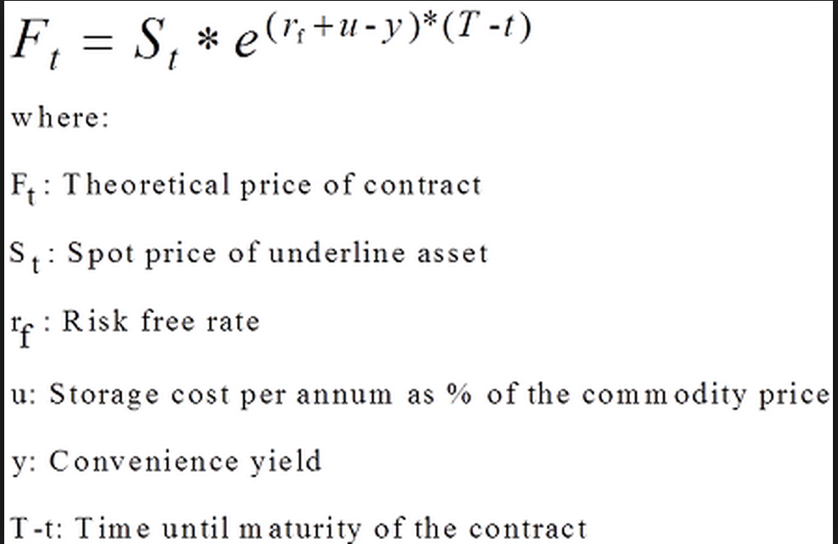

**Calendar Spread (use to make gamma and vega of option the same sign)**

 a **calendar spread** (also called a **time spread** or **horizontal spread**) is a [spread trade](http://en.wikipedia.org/wiki/Spread_trade) involving the simultaneous purchase of [futures](http://en.wikipedia.org/wiki/Futures_contract) or [options](http://en.wikipedia.org/wiki/Option_(finance)) expiring at particular date and the sale of the same instrument expiring another date. The legs of the spread vary only in expiration date; they are based on the same underlying market and strike price.

**When can Gamma and Theta have the same sign?**

1. **Deep in the money Euro Calls where dividend yield is high enough**
2. **Deep in the money Euro Puts**

**Replication of vanilla European Call:**

1. **Long “asset or nothing” binary option and short “cash or nothing” binary option**
2. **Long “knock out” and “knock in” call**

**Interest Rate Models:**

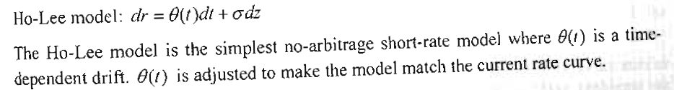

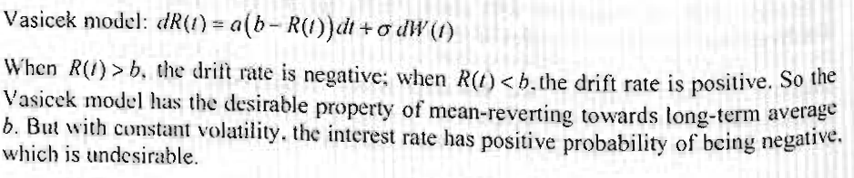

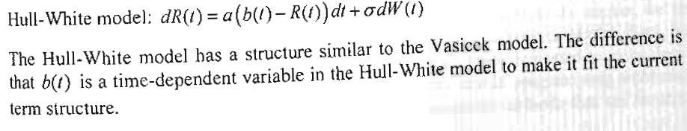

**Linear Algebra:**

Orthogonal:

A n×n matrix A is an orthogonal matrix if

|  |  |
| --- | --- |
| AA^(T)=I, | (1) |

where A^(T) is the [transpose](http://mathworld.wolfram.com/Transpose.html) of A and I is the [identity matrix](http://mathworld.wolfram.com/IdentityMatrix.html). In particular, an orthogonal matrix is always invertible, and

|  |
| --- |
| A^(-1)=A^(T). |

|  |
| --- |
| **Shortcut for 2x2 matrices**  For http://www.mathwords.com/i/i_assets/inverse%20of%20a%20matrix%20formula%202.gif, the inverse can be found using this formula:  http://www.mathwords.com/i/i_assets/inverse%20of%20a%20matrix%20formula%202b.gif |
| **Example**: http://www.mathwords.com/i/i_assets/inverse%20of%20a%20matrix%20example%202.gif |

Rank:

In linear algebra, the **rank** of a **matrix** A is the size of the largest collection of linearly independent columns of A (the column **rank**) or the size of the largest collection of linearly independent rows of A (the row**rank**). For every **matrix**, the column **rank** is equal to the row **rank**.

* Linear Dependence: When a linear function of the columns (rows) of a matrix produces a zero vector (one or more columns (rows) can be written as linear function of the other columns (rows))
* Rank of a matrix: Number of linearly independent columns (rows) of the matrix. Rank cannot exceed the minimum of the number of rows or columns of the matrix. rank(**A**) ≤ min(*r*A,*c*a)
* A matrix if full rank if rank(**A**) = min(*r*A,*c*a)

Trace

the **trace** of an n-by-n square **matrix** A is defined to be the sum of the elements on the main diagonal (the diagonal from the upper left to the lower right) of A, i.e.,

Positive Semi Definite (Matrix A)

1. Transpose(x) \* A \* x >= 0 for any n x 1 vector x
2. All eigenvalues of A are non negative
3. All upper left (or lower right) submatricies have non negative determinants

Positive Semi Definite?

* 1. xTAx >= 0 for any nx1 vector x
  2. All eigenvalues of A are >0
  3. All upper (or lower right) submatricies have positive determinants

What is i ^ I ?

= e ^ (-1/2 \* pi)

e^{ix} = \cos x +  i\sin x \,\!

Linear Regression using Matricies

Suppose *b* is a "candidate" value for the parameter *β*. The quantity *yi* − *xi*T*b* is called the [**residual**](http://en.wikipedia.org/wiki/Errors_and_residuals_in_statistics) for the *i*-th observation, it measures the vertical distance between the data point (*xi*, *yi*) and the hyperplane *y = xTb*, and thus assesses the degree of fit between the actual data and the model. The **sum of squared residuals** (**SSR**) (also called the **error sum of squares** (**ESS**) or **residual sum of squares** (**RSS**))[[5]](http://en.wikipedia.org/wiki/Ordinary_least_squares#cite_note-5) is a measure of the overall model fit:


    S(b) = \sum_{i=1}^n (y_i - x_i ^T b)^2 = (y-Xb)^T(y-Xb),
  

\hat\beta = (X^TX)^{-1}X^Ty\ . 

Chelosky Decomposition

**Fixed Income**

Spot vs Forward Rates

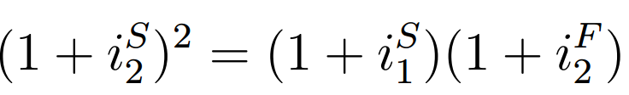

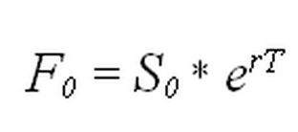

Forward Curve

If on a given date the forward curve is upward-sloping, then the market is in **contango**. If the forward curve is downward sloping, the market is in **backwardation**.

FRAs are over-the-counter contracts that guarantee a borrowing or lending rate on a given notional principal amount

Bond relationships

|  |  |  |  |
| --- | --- | --- | --- |
| **UP** | **Duration** | **DVO1** | **Convexity** |
| **T** | **UP** | **UP** | **UP** |
| **q** | **DOWN** | **UP** | **DOWN** |
| **y** | **DOWN** | **DOWN** | **DOWN** |

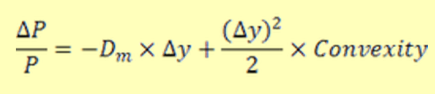

Duration

Duration approximates the percent change in price for a 100 basis point change in rates

Option Adjusted Spread –

A measurement of the spread of a fixed-income security rate and the risk-free rate of return, which is adjusted to take into account an embedded option. Typically, an analyst would use the Treasury securities yield for the risk-free rate. The spread is added to the fixed-income security price to make the risk-free bond price the same as the bond.

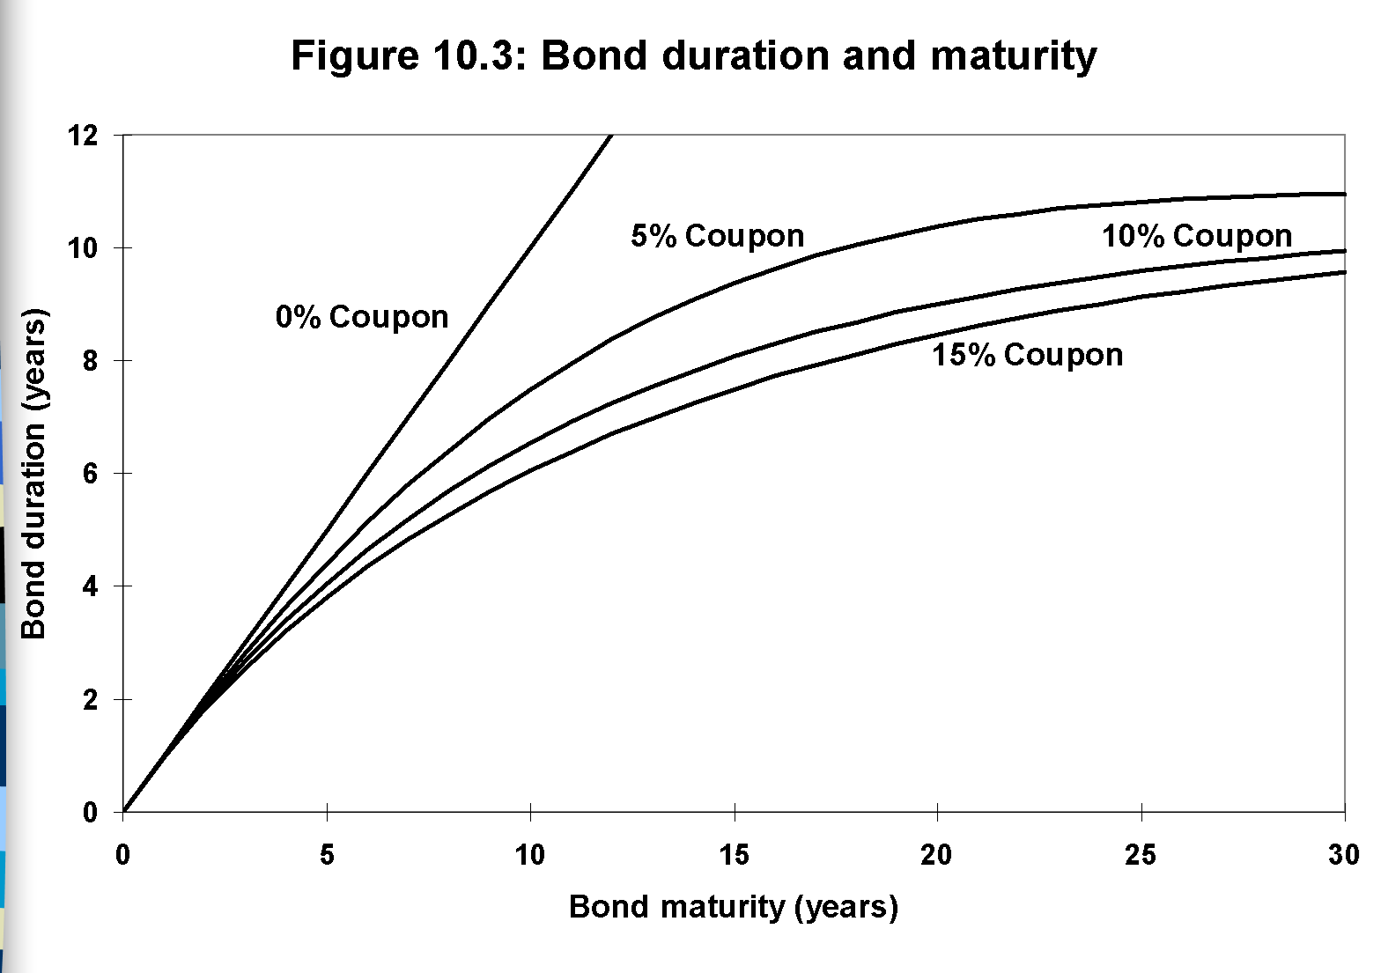

Sto Cal

What is a Brownian motion?

What is ito’s lemma?

What are some interest rate models?

**Programming**

**Horner's Rule**

**Polynomials without the power function**

The quadratic (i.e. degree 2) polynomial

y = c1 x2 + c2 x + c3

can be rearranged as

y = (c1 x + c2) x + c3

The same pattern can be applied to a cubic (degree 3) polynomial

y = c1 x3 + c2 x2 + c3 x + c4

y = (c1 x2 + c2x + c3) x + c4

Factoring the quadratic term inside the parenthesis gives

y = ( (c1 x + c2) x + c3) x + c4

This pattern is called Horner's rule for evaluating a polynomial. For hand calculation of low degree, it makes sense to use direct computation of the polynomial in its standard form. To evaluate a polynomial in a computer program, Horner's rule makes more sense, especially if speed and accuracy are important and the degree of the polynomial is large.

Here is an code that uses Horner's rule to repeatedly evaluate the same polynomial. The correct value is 1070.8.

**float horner(int n, float \*c, float x) {**

**float f;**

**f = c[0];**

**for ( int i=1; i<n; i++ ) {**

**f = f\*x + c[i];**

**}**

**return(f);**

**}**

Const

* 1. Pointer to a const

Int const \* ptr;

* 1. Const pointer to a variable

Int \* const ptr = &a;

* 1. Const pointer to a const

Int const \* const ptr = &a;

**Sorting**

**Selection Sort**

Go through each element -> pick the smallest number

Move this to the 1st position

Go through each element from 2 to n -> pick smallest number

Move this to the 2nd position

Do this until you reach n

**Bubblesort**

Go through the list 2 at a time

Compare n and n+1, if they are out of order, switch the two

Continue doing this until u reach the end

**Markets**

So prepare well. Basic stats, Fixed Income and Options are a minimum. I think I told you that I read the green book. I didn’t solve all the problems but I used this winter break to at least go through it and review some areas. Know what’s going on in the market, in broad terms. Stuff, like what caused the credit crisis, what was QE, which countries in Europe aren’t doing so well, why is oil so low, what’s up with Russia. These are major stories that you should have some basic idea of. I don’t think the interviewers are expecting too much depth but enough to start and hold a conversation for a few minutes. An investment idea or two is always good to have – I used the ones I had to come up with for presentations class.

Other than that be personable and just do your best! Let me know on how it goes. Good luck!

# What is the probability that n points picked from the circumference of a circle lie on the same semi-circle?

This can be solved using some very simple reasoning.

Say you have your circle lying in front of you. Mark your first point on its circumference. Now you need the remaining n−1n−1 points of yours to also lie on the so-called “upper-half-circle” whose left extremity is the first point.

For each of the given n−1n−1 points they can either *lie*or *not lie*on the upper-half-circle. Assuming that *all of them do lie on the upper-half-circle, you get*

(12)n−1(12)n−1

But any of your nn points can be the first point, and the argument can be extended to the remaining n−1n−1 points also. So, your required probability is

n(12)n−1n(12)n−1

***A curious mathematical diversion:***

The above probability can also be expressed as a product of the multiples of the sector angles of a semi-circle, when the semi-circle is divided into nn equal sectors. I will leave the reader to prove that

∏k=1n−1sinkπn=n2n−1

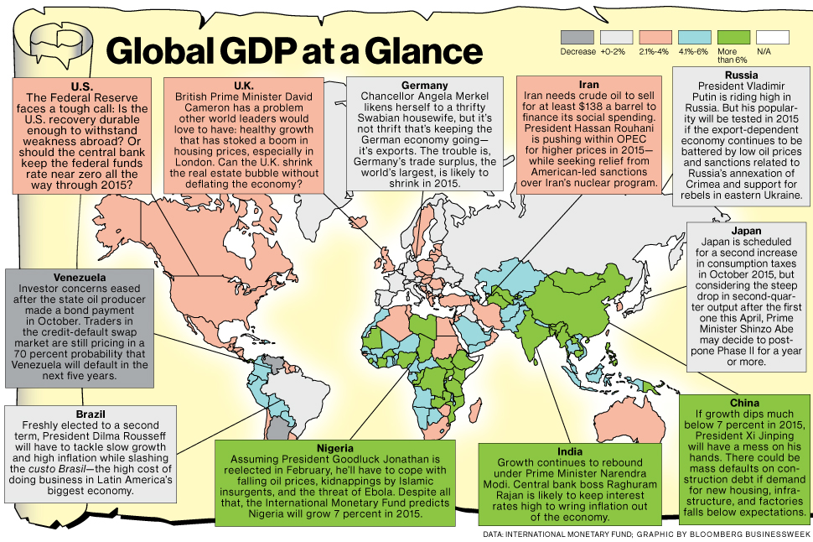

<http://www.businessweek.com/articles/2014-11-06/2015-global-economic-outlook-better-than-2014-but-not-by-much>